Monitoring Kiwi with Acoustic Recorders

Kiwi are secretive and nocturnal and it is therefore difficult to count all birds in a known area. Kiwi listening is a surveying technique that makes use of the territorial behaviour of the kiwi as they call regularly and loudly and they also have sexually dimorphic calls allowing differentiation between male and female. The limitation of kiwi listening is that it is based on calling birds (not all birds may call e.g. juveniles) and therefore only an estimation of relative abundance can be calculated.
Despite this limitation, kiwi listening still allows us to monitor how the population is changing over time i.e. is it stable, increasing or decreasing. It is also excellent at detecting kiwi presence (as kiwi calls are only heard where kiwi are) and reasonable at showing kiwi absence (if kiwi calls are not heard then there are probably no kiwi or at the most only a very small population presuming that the standard kiwi call count methodology is followed).
Kiwi listening is the most effective and efficient tool to monitor kiwi over the large area currently available to the Kiwi Coast. There is also a long history of kiwi listening occurring in many parts of the Kiwi Coast with 10-20 years of data already collected at some sites providing strong information on current population trends.

Using the Acoustic Recorder or “Kiwi Listening Device”

Provided:

- Kiwi Listening Device (KLD)
- Blank SD card 8GB minimum
- Fully Charged Batteries: 4 x AA
- Bungee cord
- Info sheet for filling in

This Kiwi Listening Device (KLD) has been pre-programmed to switch on at a preset time each night and start recording for a set number of hours.
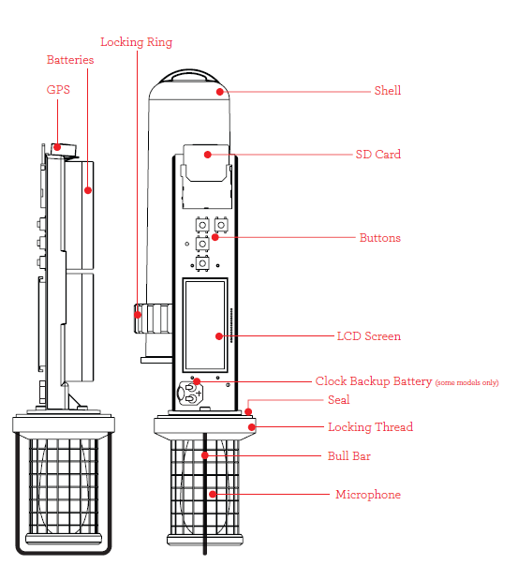

When you are ready to use the device, insert the fourth battery (taped to device) and it is good to go.

Please do not change any of the programming or adjust the settings.

Setting up the Recorder:
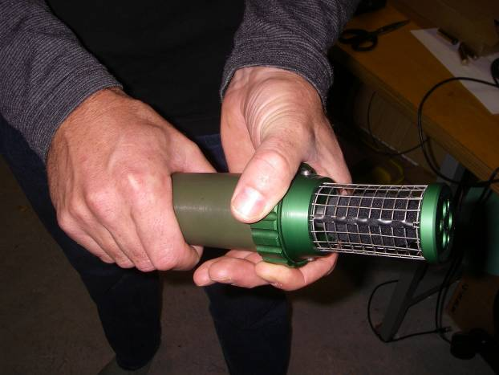
To open the KLD and insert the battery, loosen the large knurled ring, grip the plastic tube and turn the ring clockwise looking from the top of the mesh cage.

Fully unscrew the large knurled ring by gently twisting until the ring is fully unscrewed.

Avoid excessive force on the mesh microphone cover (if the locking ring is tight then grip the tube while removing it – not the microphone cover).

Once the recorder is open you can see the display screen, control buttons and SD card slot on one side, the battery holders are on the other. Try to avoid getting moisture or debris inside the recorder.

SD card:

If you are borrowing a KLD from Kiwi Coast the SD card will be formatted, cleared and ready to go. Please only use the SD card provided.

If you are going to use the KLD at more than one site it is important that you
- Change the SD card
- Replace all batteries with freshly charged ones
- Use the form provided to record the location of each place, and keep the right SD card with the right info so there is no confusion.
- Put the SD card in a packet/envelope if one has been provided and clearly label the location

NB: Do not use SD cards that have also been used in trail cams as this appears to corrupt them and make them unusable in KLDs. Please do not put Kiwi Coast SD cards in any other device.

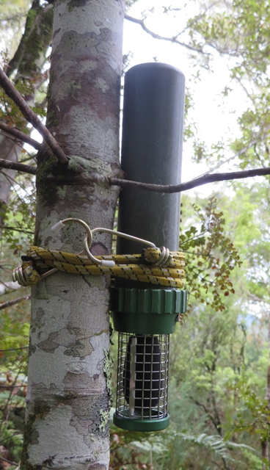
Choosing a good recording location:

KLDs can ‘hear’ about 800m – 1km in good conditions.

Give the KLD the best chance possible to record kiwi calls! Take time to choose a good spot that will give the KLD the best chance to hear sounds clearly, with minimum noise interference.

The KLD won’t be damaged by rain, but avoid putting them out in storms or high winds as this creates a lot of background noise and makes them hard to analyse.

If you’re on the coast, crashing waves can also cause a lot of noise. You may need to wait a couple of days after a storm for the swell to calm down.

Ridges can be good locations for KLDs so they can listen into wide valley systems, but try to avoid the very ridge or hill top for less wind interference.
Once you’re in a good spot, choose a tree or post to secure the KLD. Try to avoid trees that will be knocked by swaying branches, swishing fern fronds or anything that looks like it will create noise close to the KLD.

Smaller trees are better as large trees can cause unwanted blocking of the sound.

Secure the KLD at head height using bungees. Ensure it is a snug fit so that it does not rattle in the wind and curious rats and possums cannot dislodge it!

Be sure to put the KLD out with the mesh covered microphone at the base as per the picture.

Record the location:

Use a GPS or print off a map to record the location of where the Kiwi Listening Device was placed. This info is vital if KLDs are used annually for kiwi monitoring, so the device can be returned to the same site each year, and also means the data can be mapped.

Remember if you are using more than one KLD at a time, be sure to clearly mark which device was at which site so there is no confusion about where all the kiwi were heard when the data is analysed!

Batteries:

Note: the only way to stop the KLD from recording is to remove the batteries. Remove the batteries as soon as you remove the KLD from the recording location or it will keep recording and our analyser will sift through hours of data for no purpose!

Returning the equipment

- Fill in the paper form, or add in any details if partially filled in if you can
- Put the form and the SD card into an envelope or small plastic bag and seal tightly. This ensures your SD card (kiwi calls) will be recorded against the correct location!

Please return all the gear provided back to us and avoid swapping in any other SD cards, batteries or ties. We thoroughly check, clear and dry the equipment before it goes out again to minimise the chance of failure at the next site. Getting back incomplete sets of gear means the next site does not have all that they need.

Any problems or questions contact Ngaire at ngaire@kiwicoast.org.nz or ring 0274 250 249

Please fill this in for each site a KLD is used

Site name:

Name of contact person:

Email address:

Phone number:

Group or project

KLD number: SD card#:

GPS location of KLD site:
Easting Northing

Or printed map attached with site/s labelled attached. Yes/No

Date KLD out:
Date KLD in:

Dates of any stormy nights to avoid analysing:

Dates and times of any kiwi calls you heard while KLD was out:

Date: Time:

Date: Time:

How do you want the data analysed: circle one
- Analyse just 6pm – 8pm for four clear nights to mimic Annual Kiwi Call Count Survey protocols.

- Fully analyse at least 5 clear nights for total number of male and female kiwi calls, duets and retain any clear images of calls for sharing with our group/project.

Any problems or questions contact Ngaire at ngaire@kiwicoast.org.nz or ring 0274 250 249.

